d

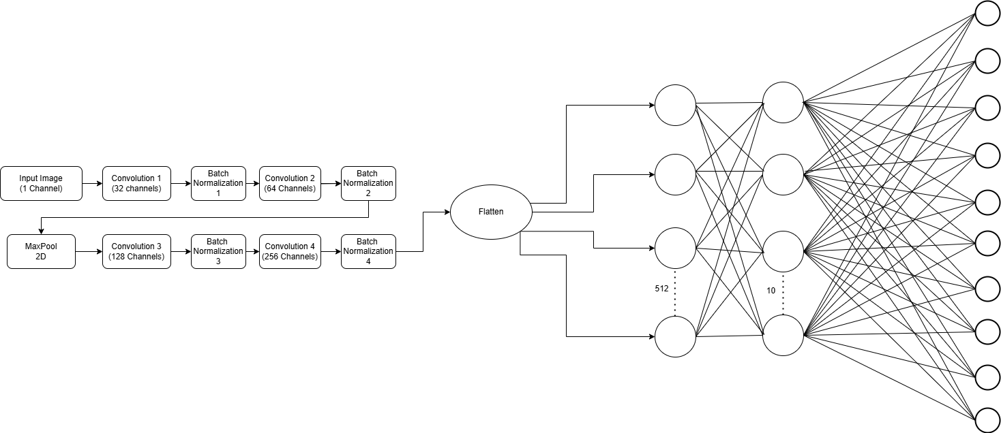

Epoch 1, Train Loss: 0.3726

Epoch 2, Train Loss: 0.2714

Epoch 3, Train Loss: 0.2444

Epoch 4, Train Loss: 0.2259

Epoch 5, Train Loss: 0.2116

Epoch 6, Train Loss: 0.2030

Epoch 7, Train Loss: 0.1907

Epoch 8, Train Loss: 0.1858

Epoch 9, Train Loss: 0.1777

Epoch 10, Train Loss: 0.1704

Epoch 11, Train Loss: 0.1634

Epoch 12, Train Loss: 0.1583

Epoch 13, Train Loss: 0.1547

Epoch 14, Train Loss: 0.1510

Epoch 15, Train Loss: 0.1456

Epoch 16, Train Loss: 0.1437

Epoch 17, Train Loss: 0.1379

Epoch 18, Train Loss: 0.1388

Epoch 19, Train Loss: 0.1347

Epoch 20, Train Loss: 0.1306

Epoch 21, Train Loss: 0.1273

Epoch 22, Train Loss: 0.1301

Epoch 23, Train Loss: 0.1255

Epoch 24, Train Loss: 0.1251

Epoch 25, Train Loss: 0.1208

Epoch 26, Train Loss: 0.1197

Epoch 27, Train Loss: 0.1186

Epoch 28, Train Loss: 0.1176

Epoch 29, Train Loss: 0.1157

Epoch 30, Train Loss: 0.1183

